Toronto, ON, Canada: Sustainable Street Development for Multimodal use

Theodore Kim

URB 3874: Sustainable Transportation in Cities

May 4, 2018

**Introduction**

Well planned streets are a critical component in the development of a sustainable urban transportation system. While subterranean and elevated transit options like heavy and light rails are often preferred amongst urban riders, the reality is that the most prolific transportation methods, private automobile and public bus[1], rely on streets as their transportation media. Therefore, having well designed streets are vital for the safe and quick operation of these modes. In addition to road-based transportation systems, street design has an impact on promoting pedestrian and bicycle transportation modes. Through various design decisions, streets could make “human” transportation a more safe and convenient option for individuals, which in turn can promote higher density forms of transportation like heavy and light rail. Hence smart street decision is vital for the development of an overall sustainable urban transportation network.

What defines a “street?” According to Merriam-Webster dictionary, a street is “a thoroughfare especially in a city, town, or village that is wider than an alley or lane and that usually includes sidewalks.”[2] Hence, the term “street” will be used to refer to the entirety of the area between buildings in a city; components of a street includes the “sidewalk,” or the pedestrian component, and the “road” or the vehicle transportation component. Similarly, vital to this paper is the concept of “street design.” Street design refers to the design decisions and principles which contribute to the street’s physical structure. Hence, it encompasses features like bike lanes or dedicated bus travel lanes. Especially important to urban planners is the use of the “in-between space” or the boundary between the sidewalk and road. It is the use of this area where streets see the most innovative use with introduction of features like dedicated bicycle lanes and parking lanes.

A close up of a street

Description generated with high confidence

Figure 1. The components of a street including the roadway and sidewalk zones, and the “in-between” zone for development.

Julian Mirabelli, “Reimagining Toronto’s Road with Complete Streets Guidelines.” Urban Toronto, last modified: March 5, 2016, http://urbantoronto.ca/news/2016/03/reimagining-torontos-roads-complete-streets-guidelines

Toronto, the subject of this paper’s case study, is a metropolis in the south eastern Canadian province of Ontario. Located on the northwestern corner of Lake Ontario, Toronto is the largest urban population center in Canada, with a population of 6.3 million people according to a 2017 Canadian population estimate.[3] The city is similarly the most population dense area in Canada, with a geographic area of 5,905 square kilometers (2,280 square miles) and an average population density of 945.4 persons per square kilometer.[4] This is significantly higher than the national average of 3.7 persons per square kilometer.[5] Being a relatively dense urban environment, Toronto has developed an extensive public transportation system including four subway lines, 11 streetcar routes and over 140 bus routes.[6] Yet, the city still has a car ownership of 85%, with 82% of resident choosing to commute via automobile daily, 12% via public transit, and 6% via bicycle or foot.[7]

Toronto’s diverse multimodal transportation offerings prove a challenge to the development of sustainable street design. While other urban environments may only require accommodations for automobile and bus traffic on its roads, Toronto’s streets must also take into account its streetcars, which require dedicated tracked embedded into roadways and stations, yet share the road with other modes of transportation. Similarly, being an old city, Toronto faces challenges presented by its historical development, like its patched gridiron street pattern, which pose challenges to its streets’ accessibility and safety. The city has attempted to address these issues through various urban planning initiatives including its Complete Streets plan, essentially using individualized street categorization in order to identify possible improvements to all of its streets in a way that would most directly benefit its users.

The effects of innovative street design on the safety and effectiveness of various pedestrian, bicycle, and road-dependent transportation modes will be discussed in the context of the city of Toronto, Ontario, Canada in this paper. This includes the city’s challenges to sustainable street design as a result of its historical development, and how the city has addressed these issues and innovated on its street design strategy. The lessons Toronto learned in street design will then be applied to the development of complete streets in New York City.

**History of Transportation and Urbanization in Toronto**

Toronto was founded in 1793 as the town of York by Lieutenant Governor John Graves Simcoe. The location of the city was chosen to be the northwest corner of Lake Ontario for its naturally shielded harbor, which Simcoe believed would enable the settlement to control Lake Ontario and the Niagara peninsula.[8] The original city was planned on two separate gridiron town-plots, a 10-block area a part of the present-day “Distillery District” and a larger 12-block parcel to its west, currently referred to as “Old Toronto”. Connecting these two streets was the modern thoroughfares of Dundas and Yonge Streets.[9]

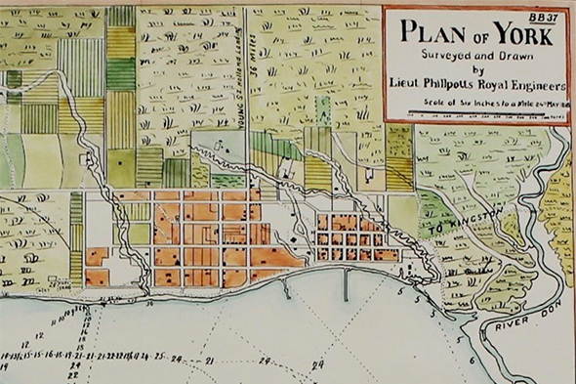

Figure 2. An historical map showing the original town plots in orange, a smaller plot to the east a larger plot to the west

Derek Flack, “Where the Toronto street grid got its start.” blogTo, last modified: November, 5, 2016, https://www.blogto.com/city/2016/11/where_the_toronto_street_grid_got_its_start/

From early in its history, street design was not a major priority to the city. In 1834, the city incorporated as Toronto to rid it of the negative connotations associated with the previous name, York. This included the nickname “Muddy York” that was derived from the city’s grossly unmaintained and unpaved streets, which were often the consistency of quicksand due to rain and runoff from streams and rivers north of the city.[10] What few roads had sidewalks, were made of flammable wooden planks.[11] The city had little resources to fix or develop the roads throughout the majority of the 19th century.[12] In fact, when the Toronto Street Railway Company (TRC) began laying down track for its horse-drawn streetcars in the 1860s, many privately owned wagons utilized the tracks to traverse the still unpaved roads.[13] During the 1890s there was an official movement by city engineers to fully pave all of the city’s streets with asphalt, the modern pavement used by roads today, which included on most streets a concrete sidewalk for non-vehicular traffic.[14] By the turn of the century, the streets were being shared by horses, early automobiles, electric streetcars and pedestrians.

The final change in the development of the contemporary streets of Toronto was the construction of the subway in the 1950s. Built in the post-war era to accommodate the growing commuter traffic along the Toronto’s busiest street, the Yonge Street subway line was constructed using a trenching method in which the subway tunnels were constructed by digging out trenched and eventually covering them with concrete and asphalt.[15] Another step taken during this time was to bury the majority of the power lines in downtown Toronto and electrify the streetcar rails in order to eliminate the need for overhead electrical lines.[16] By doing so, the need for extra space along streets to accommodate electrical poles was eliminated freeing up sidewalk area for pedestrians.

Many of the challenges the city’s streets face is due to the historical development of its transportation systems, namely the city’s street patterns as a result of its original foundation and its heavy multimodal traffic, especially in its downtown area. Both factors prove challenges to the safety of both pedestrians and cyclists, as well as increase congestions for both private and public transportation modes.

While accessible to pedestrians, the city’s gridiron network contributes to a greater crash rate amongst automobiles due to its increased permeability; the more cars share the same road, the greater the risk for collision.[17] Also due to its standardized gridiron development, Toronto lacks the “major and minor street” system that is common in urban areas like New York, where high traffic avenues are connected by low traffic streets.[18] As a result, it is common to have several bidirectional, multilane streets width widths greater than 10 feet (3.1m) intersecting with one and other,[19] which results in an increased crash rate as cars make turns less cautiously, and are more likely to get into an accident.[20] Gridiron street patterns also prove less safe for cyclists who are more likely to have to cross traffic with an increased number of intersections characteristic of gridiron networks, thus increasing their chance of collision with a turning automobile.[21] Therefore street design decisions must take into account the safety concerns posed by the gridiron pattern.

Toronto’s multimodal road use is also both a blessing and a curse to its street network and must be addressed in any sustainable street design standards that the city implements. In Toronto, the majority of street car lines operate on nondedicated track, in other words, track that shares right-of-way with private automobiles and cars on the road. This poses a unique threat of cross modal collisions and congestion. In 2014, the Toronto Transit Commission reported, nearly 18,000 crashes between its streetcar, bus and Wheel-Trans (Toronto’s Paratransit system) systems over a five-year period, the majority of which were deemed to have been “unavoidable.”[22] Congestion is also the result of shared modal traffic on streets, with the primary source being that the majority of streetcars do not have dedicated lanes or sidewalk boarding, requiring passengers to cross the street to enter the streetcar, holding up traffic in the process.[23] The average TTC streetcar and buse experiences ten to twenty minutes of delays daily due to traffic congestion, with an estimate $1.7 million (CAD) in lost revenue.[24] These issues could be solved with smarter street signaling, dedicated travel lanes (which some streets in Toronto already have completed) and better passenger boarding options for the various modes.

**Toronto’s Innovation in Street Design**

Though historically ineffective in solving street infrastructure issues, Toronto has been recently making steps towards improving its thoroughfares with sustainable street design standards through various planning initiatives. The goals of said plans are to make streets friendlier to public transit, cyclists and pedestrians, and to deprioritize low density automobile traffic. The city’s Complete Streets guidelines will be discussed as the driving document for sustainable street design.

“Complete streets” is not a concept unique to Toronto but is a design initiative which aims to design streets “for all users and use cases,”[25] in other words, to accommodate modes of transportation outside of automobile and vehicular traffic. The complete street design standard was created with National Complete Streets Coalition, an urban design advocacy group, in 2005.[26] While it does not include a concrete codes of standards, the general concepts behind the project include the reduction of traffic lane width to reduce urban traffic speed, the created of protected, dedicated bike lanes, addition of “green space” to sidewalks, and traffic islands to reduce pedestrian crosswalk length and reduce turning speeds between major thoroughfares.[27]

In March 2016, the Toronto Design Review Panel introduced the city’s version of Complete Streets as a standard for future street development and renovation.[28] The standard prioritizes pedestrians and cyclists, then public transit, and places private automobiles at the lowest priority for street usage as it has identified those modes as being the most sustainable options for urban transportation.[29] Hence, the plan promotes a new design paradigm of “outside in development”—focusing on *multimodal* safety and accessibility—rather than the traditional automobile-centric “inside out approach.” Such a paradigm called for reduced roadway zone size, and increased utilization of the “in-between zone” for cross modal accommodation and safety.[30]

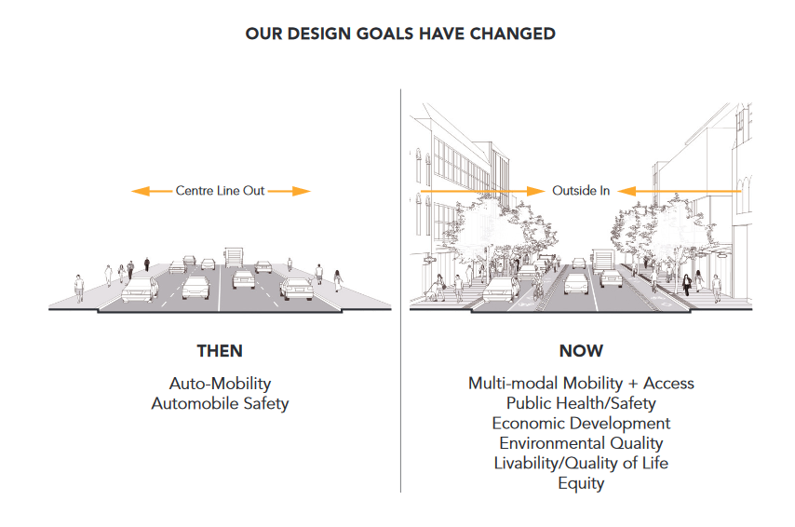

Figure 3. A comparison the “inside out” paradigm (left) versus the Complete Street’s “outside in” paradigm

“Complete Streets Guidelines”: 11

Another feature of the city’s version of the initiative is to identify types of streets and make guidelines specific to each street’s usage pattern and population rather than assuming a “one size fits all” approach.[31] In doing so, the city will be better able to allocate resources to streets whose design much be changes radically, like the city’s commercial districts, compared to streets whose current layout is sufficient for sustainable development, such as residential streets. The plan identifies several road types, and the main categories are outlined in Figure 4.

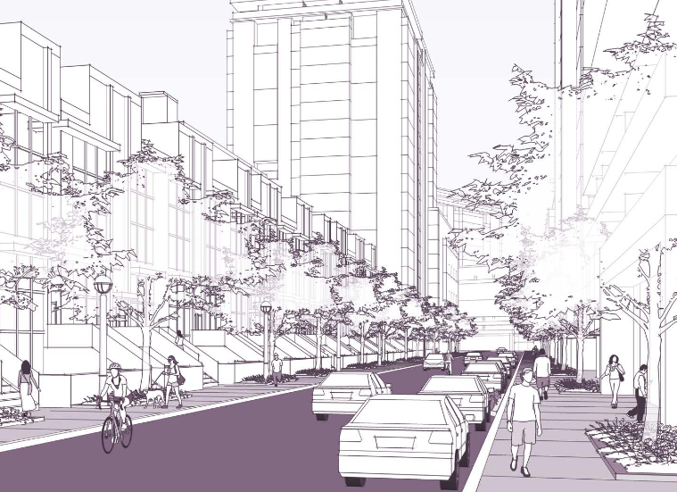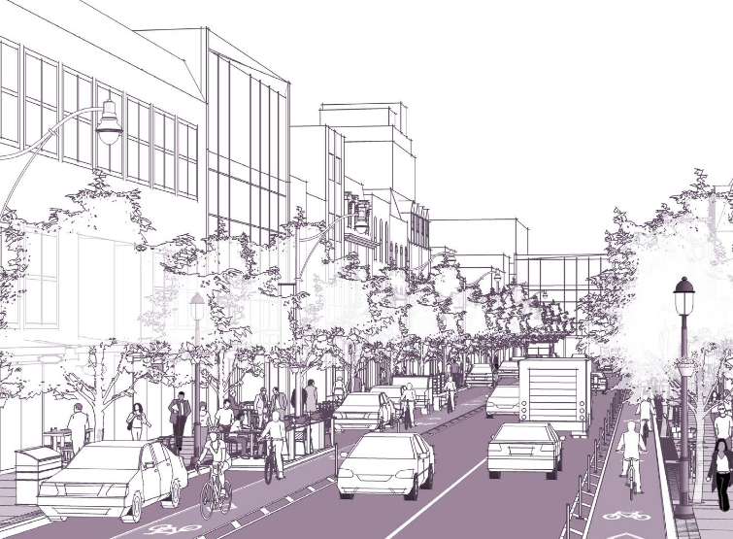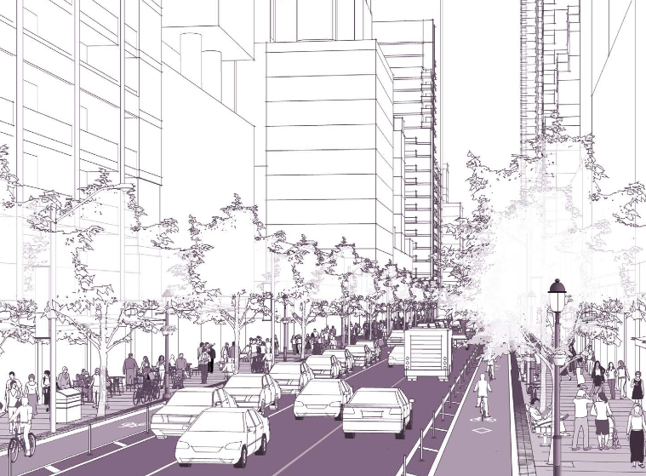

**Low-Density Residential**

**Downtown Commercial**

**Avenue / Neighborhood Main St.**

Figure 4. Three of the street categories identified by Toronto’s Complete Streets plan. From left to right: **Downtown Commercial:** high cross modal traffic and community exposure, bidirectional streets to promote traffic flow, dedicated parking lanes outside of cycling lanes to slow traffic and protect cyclists / pedestrians, **Low-Density Residential**: low automobile traffic, little cross modal traffic, emphasis on parking and reduction of permeability with a single unidirectional lane, **Avenue / Neighborhood Main St.**: reduce traffic by narrowing cross modal lanes, extended sidewalks to improve pedestrian crossings and expose sidewalks to public transit boarding, unexposed parking lane to reduce parking turnover.

“Complete Streets Guidelines”: 11

Finally, the plan identifies changes that could be made to the city’s streets in order to improve riders’ experience on public transit and improve on safety and congestion issues discussed in the previous section. The development of sidewalk “bulb-outs” or portions of the sidewalk that extend into the parking or bike line to allow seamless transfer of pedestrians from the sidewalk to buses or streetcars, would improve rider’s safety and traffic flow.[32] It also proposes the allotment of reserved transit lanes for buses, streetcars and similar “high occupancy vehicles,” to prevent delays and facilitate the movement of as many individuals as possible. The plan makes allowances for shared lanes on streets where a dedicated lane cannot be spared for a single mode. In such cases improves signaling can be used to synchronize traffic with passenger boarding of buses and streetcars.[33]

Toronto’s Complete Streets guidelines are by no means new to the city, but are codifications of the city’s twenty years of experience in sustainable urban planning. The city has already completed several large street design projects using the principles of its Complete Street standards and continues to move forward on various other projects such as the Adelaide Street bike lane addition which conform to the recently introduced Complete Street standards. One of the largest projects to adopt a Complete Street standard in Toronto to existing roadway in Toronto is renovation of downtown Yonge Street. Although the project began before the formal introduction of the Complete Streets guidelines, the Yonge Street rework is an example of the effectiveness of its design principles.[34] Yonge Street serves as Toronto’s primary thoroughfare and previously featured four bidirectional travel lanes, which were since reduced to two travel lanes. The created space was utilized for pedestrian plazas, dedicated bicycle lanes, and increased green space. A pedestrian plaza was created at Yonge’s intersection with yet another busy street, Dundas, to serve as Toronto’s version of New York City’s Times Square.[35] A later economic impact study estimated 10 – 20% increase in retail activity since the street’s redesign, a 30% increase in pedestrian traffic in the area, and a 70% reduction of automobile related injuries on the revised stretch of street.[36] The success and the experience of the Yonge Street redesign prompted the development of a codified Complete Streets guidelines and is demonstrative of the effectiveness of well designed streets to encourage cross modal transportation and economic development.

**Lessons Learned from Sustainable Street Design in Toronto**

Aside from the Yonge Street redesign project, two other Complete Street projects have been completed in Toronto: St. George Street (1997) and Queens Quay (2015).[37] These street redesign projects will be evaluated for their effectiveness in utilizing the Complete Street guidelines and their completion of the programs’ goals overall. These goals include the promotion of pedestrian traffic and cycling, the improvement of cross modal accessibility, and the reduction of automobile traffic. Moreover, Toronto’s approach towards addressing common concerns with sustainable street renovations will be examined in the context of these project case studies.

The St. George Street Revitalization Project was dubbed a “road diet” as it involved the reduction of the road’s four travel to two.[38] The project’s main goal was to reduce vehicular traffic as a means of improving pedestrian, cyclist and rider safety. St. George Street was classified as an “avenue” street with significant vehicular usage, yet also significant pedestrian traffic. Hence the street was identified as a location in need of a redesign to promote cross modal transportation usage. The St. George project added a dedicated, protected cycling lane, widened the sidewalks, and planted more greenery (i.e. trees) alongside the street as a means of both beautifying the street and protecting pedestrians from the busy vehicular thoroughfare. The project was started in 1994 and completed in 1997 and resulted in a reduction of vehicle speeds, collisions, an increase in bicycle utilization, and the utilization of the street for community events.[39]

A common voice of opposition to street redesigns such as those performed on St. George Street are from private automobile owners who are concerned about the reduction of the vehicular traffic priority. On the contrary, street redesigns benefits drivers without affecting their daily behavior. The St. George Street redesign saw a reduction of vehicle collisions by 40% (from 1991 to 2003), while the number of recorded speed violations along the street were reduced from 103 in 1994 to 21 in 2003.[40] Both of these reductions came with no measurable change in vehicle traffic over the same period of time and a 10% increase in cyclist traffic, as reported by the Toronto Department of Transportation.[41] Hence, rather than impeding private automobile driver’s usage of the street it improved their overall experience and safety.

Another common impediment to sustainable street design is the capital cost of renovation projects which are often seen as an unnecessary infrastructure cost to the city (as the saying goes, “if it isn’t broken, don’t fix it”). To offset the cost of the project, the city partnered with the University of Toronto, whose downtown campus was largely centered around St. George Street, to fund the project.[42] The city proposed that improving the street would also improve the quality of life of those who utilize it, including the university and its students. This policy of public and private capital investment would be used in future complete street projects as such redesigns could benefit both private and public interests.[43] While the St. George Street redesign came with its challenges, overall, its positive effects provided the justification for later “road diet projects” on Lansdowne and the Oriole Parkways.[44]

Queens Quay is both a busy boulevard and waterfront recreational area, similar to the West Side highway in New York City.[45] Prior to the redesign of the streets, Queens Quay had four automobile travel lanes, two segregated (sans physical barrier) street car track lanes, a pedestrian promenade and sidewalk. Similar to the St. George revitalization, Queens Quay’s travel lanes were reduced in order to improve its pedestrian and public transit accommodations.[46]

The renovation of Queens Quay, which cost $128.9 million, was started in 2007 and completed in 2015.[47] Changes made to the street are depicted in Figure 5. Further improvements included adding curbside ramps for streetcar boarding, a reduction of the speed limit from 50km/hr to 40km/hr, and prioritized signaling for street cars. As a result of these changes, later surveys conducted in 2015 showed an 190% increase in weekend streetcar utilization and 888% in weekend cyclists from 2007, largely due to the addition of the new “multiuse trail,”[48] and in a study conducted by the University of Toronto 79% of surveyed pedestrians said that the redesign improved their experience while utilizing Queens Quay.[49]

Similar to the St. George Street project, the Queens Quay redesign ran into funding difficulties early on, as the city council only initially allocated $5 million of the projected $100 million cost (later inflated to $128 million).[50] The city leveraged both private investment and provincial urban development funding as a means of fully funding the project.[51]

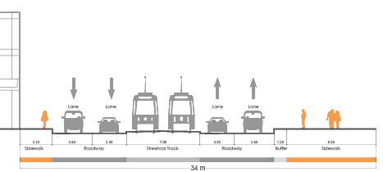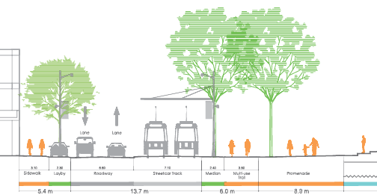

Figure 5. Queens Quay cross section from before (left) and after (right) the redesign. Notable is visible utilization of the “outside in design philosophy”: the reduction of travel lanes from four automobile lanes to two, the addition of a parking lane, the addition of a raised median between vehicle lanes and pedestrian traffic, and the addition of a multiuse trail (cycling and walking) separating the existing promenade from road. By placing the streetcar lanes next to the sidewalk, passenger boarding safety was also improved.

“Queen’s Quay Toronto”

Canada, as a country, is quickly adopting a more sustainable street design system. Particularly, the city of Vancouver in British Columbia has developed a unique Complete Streets implementation strategy. In 2017, the Vancouver City Council adopted a policy to allow city employed engineers and urban planners to initiate minor street alterations in accordance with the city’s Complete Streets framework without previous approval from the city council.[52] Such autonomy is vital to the development of a better urban design strategy, given that many Complete Street goals can be accomplished with minor alterations such as changing parking regulations and repainting lane dividers. After passing said measure, the number of urban design renovations undertaken in Vancouver increased by nearly 600%.[53]

These examples of sustainable street designs are demonstrative of the positive effects that smart urban planning can have on controlling transit usage and safety in a city. Moreover, the improvement of the city residents’ quality of life as a result of Toronto’s street redesigns is proof of the importance of streets to the development of a sustainable and enjoyable urban environment. However, to achieve such measures, joint private and public cooperation as well as smart administrative policy is needed for effective implementation of Complete Streets.

**Applying Sustainable Street Design to New York City and other Urban Environments**

Complete streets is a global movement that is shifting the paradigm of urban planning as a means of developing an overall sustainable transportation network. New York City is uniquely set up for the development of a more sustainable street design model. Particularly Manhattan has redesigned many of its avenues to include protected, dedicated bike lanes and improved pedestrian safety through the inclusion of crossing islands—two examples of such innovation are shown in Figure 6. In a city where the 12% of residents cycle at least once a week[54], creating a safer environment for said cyclists along roadways is an important goal of sustainable street design in the city.

The challenges facing New York City and sustainable street design are the importance of automobile transportation to the city (lacking street level mass transit such as Toronto’s Streetcar) and the Manhattan gridiron street layout. With a 47% private car ownership[55] and 600,000 daily for-hire automobile (i.e. yellow taxis, private livery taxis, Uber, Lyft, etc.) trips,[56] New York City’s sustainable street design must balance automobile street accessibility and pedestrian safety. Therefore, the city’s approach towards “road dieting is to narrow travel lanes rather than remove them to achieve the same travel speed reduction (drivers are more cautious driving in narrower lanes) and free up real estate for pedestrian and cyclist accommodations without sacrificing road capacity.[57]

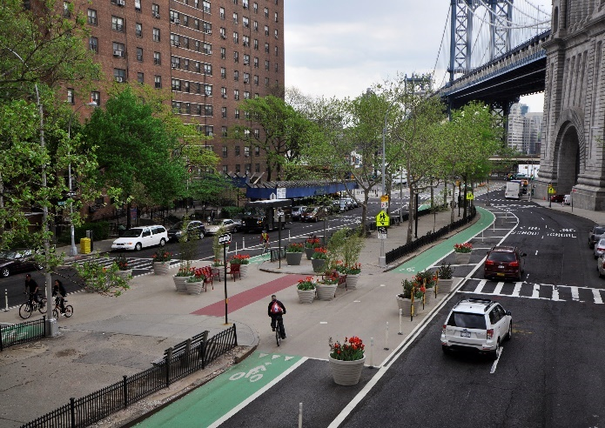 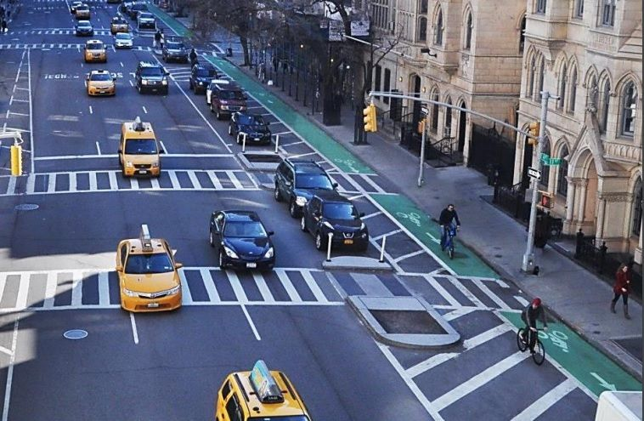

Figure 6. Examples of sustainable street design in New York City. Allan St. (left) includes a center pedestrian mall surrounded by two bidirectional bike lanes (the street formally includes travel lanes and an elevated track. 7th Avenue (right) prioritizes high vehicular traffic volume, but implements a protected bike lane and crossing islands for pedestrians.

Hinds and Ibarra, “NYC to Install a Record Number of Protected Bike Lanes this Year”

While Manhattan’s standardized gridiron network is detrimental to pedestrian safety (as previously explained) it does lend itself to the targeted street design, as seen in Toronto. In other words, New York City streets can be renovated to fit each street’s daily usage patterns, control pedestrian and cyclist traffic, and highlight tourism and commercial opportunities. For example, one-way avenues can adopt a protected cycling lane and crossing islands, yet still accommodate vehicular traffic. However, narrower cross streets have less room to accommodate sustainable use modes and automobile traffic. As demonstrated in Toronto, the identification of specific cross streets in which reducing automobile traffic by replacing road access with side accommodations would not only help direct automobile and cyclist traffic, but also highlight the local neighborhood along that street.

Sustainable street design is not purely about promoting pedestrianism, but also about improving the city’s access to and experience using public transportation. While New York City no longer has a streetcar system, its buses are a viable street level transportation option, especially for those looking to travel cross town in Manhattan or within the outer boroughs. However, these buses suffer from reduced travel speeds, traffic congestion and lack of convenient accessibility options. As a result of these problems, NYC bus ridership decreased from 2,287,098 average weekly riders in 2009 to 2,038,119 average weekly riders in 2016.[58] As seen in Toronto, segregating public transit lanes is the best way to both improve system safety and reliability. Adding a dedicated public transit lane *with* a physical barrier to prevent automobile crossover with accommodations such as raised curb access is similarly an urban design strategy that New York City should look to add to its sustainable development strategy.

While New York City has made some great strides towards the development of sustainable street design, it still lacks widespread implementation of these policies in its outer boroughs. Arguably, these areas need sustainable street renovation the most as the outer borough have a higher private automobile ownership (as high as 93.55% in Staten Island)[59] and the are the location of the majority of traffic related injuries occur in New York City (23.6% - 29.2% in the outer boroughs compared to 16.9% in Manhattan).[60] Currently, only eight outer borough street projects are being pursued by the city, several of which have been delayed due to budgetary planning complications. To achieve a truly sustainable street design network, development must be conducted evenly throughout the city, with increased effort to identify and target areas whose renovation can have the largest impact on the surrounding transportation environment.

**Conclusion**

Toronto’s unique transportation history has made the city a prime candidate for using sustainable street design to improve its transportation infrastructure as a means of improving street safety and public transit effectiveness. Specifically, the multimodal utilization of the city’s streets by its buses, streetcars and automobiles and its mixture of gridiron and offset parallel street patterns were biproducts of its development and threats to its transportation network.

The city adopted the Complete Street guidelines in order to improve its streets’ sustainability. The policy identifies and classifies streets based on its usage patterns and environment, then custom tailors renovation and development strategies based on those findings. A main feature of its design philosophy is its prioritization of sidewalk and “in-between” zones—the area between the sidewalk and road utilized for accessories such as cycling lanes—while reserving road space for public transportation over private automobiles.

Street redesign projects completed by the city tried to achieve three primary goals: reduce traffic speed to improve safety, improve accommodations for pedestrians and bicycles as a means of improves streets’ capacities as a recreational space and transportation medium, and improve accessibility to public transit options. Projects such as the Yonge / Dundas Street -pedestrian plaza and Yonge Street reduction, created more recreational space for the city’s residence and improved public and private transportation mode safety. Targeted renovations such as the Queen’s Quay and St. George Street developments improved both cyclist utilization and public transportation access. Both projects also were built on public and private cooperation, for streets have the capacity to benefit all sectors of urban society.

New York City, while having initiated several smart street design decisions, is still far away from a widespread implementation of a sustainable street network. It should adopt similar policies as seen in Toronto, particularly, sourcing funding from both the private and public sectors and targeted street design. A more proactive approach towards managing the city’s streets, particularly in the outer boroughs can help improve both public and private transportation efficiency and safety.

Sustainable transportation is not a simple concept to define. In fact, to do so would most likely omit the complex network of influences that urban transportation systems have on public and private infrastructure, residential quality of life, tourism, and commercial enterprise. Being the only transportation infrastructure that are utilized by everyday by all residents of a city, streets should be the subject of the most reform as a foundation for a more sustainable urban transportation system as whole. As demonstrated by the policies of the city of Toronto, better street design can lead to increased cycling rates, better utilization of public transit and safer conditions for both vehicles and pedestrians. Overall smart streets have the potential to revolutionize an entire urban environment.

**Bibliography**

“A Brief History of Transit in Toronto.” Transit Toronto, last modified: June 25, 2015, https://transit.toronto.on.ca/spare/0012.shtml

“A Provincial Centre, 1793 – 1851.” The History of Toronto, last modified: June 9, 2015, https://www.toronto.ca/explore-enjoy/history-art-culture/museums/virtual-exhibits/history-of-toronto/a-provincial-centre-1793-1851/

Brian B. Bettencourt, “Toronto to narrow traffic lanes in hopes of increasing safety.” *The Globe and Mail*, last modified: November 24, 2014, https://www.theglobeandmail.com/news/toronto/toronto-to-narrow-traffic-lanes-in-hopes-of-increasing-safety/article21743109/

“Bicyclists Network and Statistics.” *New York City Department of Transportation*, last modified: February 2018. http://www.nyc.gov/html/dot/html/bicyclists/bikestats.shtml

“Canada’s First Subway.” Toronto City Government, accessed: March 7, 2018, https://www.toronto.ca/city-government/accountability-operations-customer-service/access-city-information-or-records/city-of-toronto-archives/whats-online/web-exhibits/canadas-first-subway/

“Complete Street Guidelines.”City of Toronto, last modified: November 5 2017, https://www.toronto.ca/services-payments/streets-parking-transportation/enhancing-our-streets-and-public-realm/complete-streets/complete-streets-guidelines/: 1 – 3

“Congestion? It’s the streetcars, stupid.” The Toronto Sun, last modified: May 17, 2017, http://torontosun.com/2017/05/16/congestion-its-the-streetcars-stupid/wcm/ba646b51-6c19-41b0-906f-3bef6966d063

David Wencer, “The Roads to Muddy York.” Heritage Toronto, last modified: January 7, 2013, http://heritagetoronto.org/the-roads-to-muddy-york/

Derek Flack, “Where the Toronto street grid got its start.” blogTo, last modified: November, 5, 2016, https://www.blogto.com/city/2016/11/where_the_toronto_street_grid_got_its_start/

“Downtown Yonge Street, Toronto, Ontario.” Complete Streets for Canada, last modified: February 2015, http://completestreetsforcanada.ca/examples/downtown-yonge-street-toronto-ontario

Edwin C. Guillet, *Toronto: From Trading Post to Great City*. (Toronto: The Ontario Publishing Co.: 1934), 56

Eric Andrew-Gee, “TTC reports nearly 18,000 crashes since 2009.” The Toronto Star, last modified: July 4, 2014, https://www.thestar.com/news/gta/2014/07/04/ttc_reports_nearly_18000_crashes_since_2009.html

“General Information.” Toronto Transit Commission, accessed: March 8, 2018, http://www.ttc.ca/Routes/General_Information/General_Information.jsp

General Manager of Engineering Services to Vancouver City Council, April 19, 2017, Administrative Report. Vancouver City Council Archives. http://council.vancouver.ca/20170516/documents/rr2.pdf

Matthew J. Roorda, *Toronto Area Car Ownership Study: A Longitudinal Survey and a Preliminary Analysis of Results*, Master's thesis, University of Toronto, 1998 (Ottawa: National Library of Canada, ON), 66.

Phillip Gordon Mackintosh, “Asphalt Modernism on the Streets of Toronto, 1890–1900,” *Material Culture Review* 62, Fall: 7

John Spears, “Slow Start for a new Queen’s Quay.” The Start, last modified: September 2009. https://www.thestar.com/news/gta/2009/09/11/slow_start_for_a_new_queens_quay.html

Julian Mirabelli, “Reimagining Toronto’s Road with Complete Streets Guidelines.” Urban Toronto, last modified: March 5, 2016, http://urbantoronto.ca/news/2016/03/reimagining-torontos-roads-complete-streets-guidelines

“New Yorkers and Cars.” *New York City Economic Development Corporation*, last modified: April 5, 2012. https://www.nycedc.com/blog-entry/new-yorkers-and-cars

“National Complete Streets Coalition.” Smart Growth America, date accessed: March 9, 2018, https://smartgrowthamerica.org/program/national-complete-streets-coalition/

“Queens Quay and Water’s Edge Revitalization.” Urban Toronto, last modified May 2015. http://urbantoronto.ca/database/projects/queens-quay-waters-edge-revitalization

“Queens Quay, Toronto.” Complete Streets for Canada, last modified: September 2016, http://completestreetsforcanada.ca/visualizing/queens-quay-toronto

Safer Streets, Stronger Economies.” Smart Growth America, last modified: March 2015, https://smartgrowthamerica.org/app/uploads/2016/08/safer-streets-stronger-economies.pdf

“St. George Street Revitilization: ‘Road Diets in Toronto’.” Transport Canada, last modified: August 26, 2010, http://data.tc.gc.ca/archive/eng/programs/environment-utsp-st-1171.georgestreetrevitalization.htm

“Street,” Merriam-Webster.com, accessed: March 7, 2018. https://www.merriam-webster.com/dictionary/street.

“Street Design Manual.”New York City Department of Transportation, last modified: December 2015, http://www.nyc.gov/html/dot/downloads/pdf/nycdot-streetdesignmanual-interior-lores.pdf: 84

“Table 11.IV.D MTA Bus Ridership – Statistics 2009 – 2016.” NYC Data (Baruch College), last modified: August 2017. http://www.baruch.cuny.edu/nycdata2/travel/mta-busridership.html

“Table 4-4: Urban Transit Ridership by State and Transit Mode: 2013.” Bureau of Transportation Statistics, last modified: July, 2015, https://www.rita.dot.gov/bts/sites/rita.dot.gov.bts/files/publications/state_transportation _statistics/state_transportation_statistics_2015/chapter-4/table4_4.

“Toronto, Ontario: Complete Streets Policy.” Complete Streets for Canada, last modified: March 2017, http://completestreetsforcanada.ca/policy/toronto-ontario

“The 2014 Taxicab Factbook.” *New York City Taxi and Limousine Commission*, published: June 2014. http://www.nyc.gov/html/tlc/downloads/pdf/2014_taxicab_fact_book.pdf

“Traffic Accidents in New York City (March 2014 – April 2015).” Auto Insurance Center, accessed: April 25, 2018. https://www.autoinsurancecenter.com/traffic-accidents-in-new-york-city.htm

“Vancouver, British Columbia.” Complete Streets for Canada, last modified September 2017

Wesley Earl Marshall and Norman W. Garrick, “Does street network design affect traffic safety?,” *Accident Analysis and Prevention* 43 (2011): 769 – 781

1. “Table 4-4: Urban Transit Ridership by State and Transit Mode: 2013.” Bureau of Transportation Statistics, last modified: July, 2015, https://www.rita.dot.gov/bts/sites/rita.dot.gov.bts/files/publications/state_transportation _statistics/state_transportation_statistics_2015/chapter-4/table4_4.
2. “Street,” Merriam-Webster.com, accessed: March 7, 2018. https://www.merriam-webster.com/dictionary/street.
3. “Focus on Geography Series: Census metropolitan area of Toronto, Ontario.” Statistics Canada, last modified: February 21, 2016, http://www12.statcan.gc.ca/census-recensement/2011/as-sa/fogs-spg/Facts-cma-eng.cfm?LANG=Eng&GK=CMA&GC=535
4. Ibid.
5. Ibid.
6. “General Information.” Toronto Transit Commission, accessed: March 8, 2018, http://www.ttc.ca/Routes/General_Information/General_Information.jsp
7. Matthew J. Roorda, *Toronto Area Car Ownership Study: A Longitudinal Survey and a Preliminary Analysis of Results*, Master's thesis, University of Toronto, 1998 (Ottawa: National Library of Canada, ON), 66.
8. “A Provincial Centre, 1793 – 1851.” The History of Toronto, last modified: June 9, 2015, https://www.toronto.ca/explore-enjoy/history-art-culture/museums/virtual-exhibits/history-of-toronto/a-provincial-centre-1793-1851/
9. Derek Flack, “Where the Toronto street grid got its start.” blogTo, last modified: November, 5, 2016, https://www.blogto.com/city/2016/11/where_the_toronto_street_grid_got_its_start/
10. David Wencer, “The Roads to Muddy York.” Heritage Toronto, last modified: January 7, 2013, http://heritagetoronto.org/the-roads-to-muddy-york/
11. Ibid.
12. Edwin C. Guillet, *Toronto: From Trading Post to Great City*. (Toronto: The Ontario Publishing Co.: 1934), 56
13. “A Brief History of Transit in Toronto.” Transit Toronto, last modified: June 25, 2015, https://transit.toronto.on.ca/spare/0012.shtml
14. Phillip Gordon Mackintosh, “Asphalt Modernism on the Streets of Toronto, 1890–1900,” *Material Culture Review* 62, Fall: 7
15. “Canada’s First Subway.” Toronto City Government, accessed: March 7, 2018, https://www.toronto.ca/city-government/accountability-operations-customer-service/access-city-information-or-records/city-of-toronto-archives/whats-online/web-exhibits/canadas-first-subway/
16. Ibid.
17. Wesley Earl Marshall and Norman W. Garrick, “Does street network design affect traffic safety?,” *Accident Analysis and Prevention* 43 (2011): 769 - 781
18. Brian B. Bettencourt, “Toronto to narrow traffic lanes in hopes of increasing safety.” *The Globe and Mail*, last modified: November 24, 2014, https://www.theglobeandmail.com/news/toronto/toronto-to-narrow-traffic-lanes-in-hopes-of-increasing-safety/article21743109/
19. Ibid
20. Wesley Marshall and Norman Garrick, 769 - 781
21. Ibid, 789 - 790
22. Eric Andrew-Gee, “TTC reports nearly 18,000 crashes since 2009.” The Toronto Star, last modified: July 4, 2014, https://www.thestar.com/news/gta/2014/07/04/ttc_reports_nearly_18000_crashes_since_2009.html
23. “Congestion? It’s the streetcars, stupid.” The Toronto Sun, last modified: May 17, 2017, http://torontosun.com/2017/05/16/congestion-its-the-streetcars-stupid/wcm/ba646b51-6c19-41b0-906f-3bef6966d063
24. Ibid.
25. “National Complete Streets Coalition.” Smart Growth America, date accessed: March 9, 2018, https://smartgrowthamerica.org/program/national-complete-streets-coalition/
26. Ibid.
27. “Safer Streets, Stronger Economies.” Smart Growth America, last modified: March 2015, https://smartgrowthamerica.org/app/uploads/2016/08/safer-streets-stronger-economies.pdf
28. Julian Mirabelli, “Reimagining Toronto’s Road with Complete Streets Guidelines.” Urban Toronto, last modified: March 5, 2016, http://urbantoronto.ca/news/2016/03/reimagining-torontos-roads-complete-streets-guidelines
29. “Complete Street Guidelines.”City of Toronto, last modified: November 5 2017, https://www.toronto.ca/services-payments/streets-parking-transportation/enhancing-our-streets-and-public-realm/complete-streets/complete-streets-guidelines/: 1 - 3
30. Ibid.
31. Ibid, 15 - 20
32. Ibid, 105 - 106
33. Ibid, 104
34. “Downtown Yonge Street, Toronto, Ontario.” Complete Streets for Canada, last modified: February 2015, http://completestreetsforcanada.ca/examples/downtown-yonge-street-toronto-ontario
35. Ibid.
36. Ibid.
37. “Toronto, Ontario: Complete Streets Policy.” Complete Streets for Canada, last modified: March 2017, http://completestreetsforcanada.ca/policy/toronto-ontario
38. “St. George Street Revitilization: ‘Road Diets in Toronto’.” Transport Canada, last modified: August 26, 2010, http://data.tc.gc.ca/archive/eng/programs/environment-utsp-st-1171.georgestreetrevitalization.htm
39. Ibid.
40. Ibid.
41. Ibid.
42. Ibid.
43. Ibid.
44. Ibid.
45. “Queens Quay and Water’s Edge Revitalization.” Urban Toronto, last modified May 2015. http://urbantoronto.ca/database/projects/queens-quay-waters-edge-revitalization
46. “Queens Quay, Toronto.” Complete Streets for Canada, last modified: September 2016, http://completestreetsforcanada.ca/visualizing/queens-quay-toronto
47. Ibid.
48. Ibid.
49. Ibid.
50. John Spears, “Slow Start for a new Queen’s Quay.” The Start, last modified: September 2009. https://www.thestar.com/news/gta/2009/09/11/slow_start_for_a_new_queens_quay.html
51. Ibid.
52. General Manager of Engineering Services to Vancouver City Council, April 19, 2017, Administrative Report. Vancouver City Council Archives. http://council.vancouver.ca/20170516/documents/rr2.pdf
53. “Vancouver, British Columbia.” Complete Streets for Canada, last modified September 2017.
54. “Bicyclists Network and Statistics.” *New York City Department of Transportation*, last modified: February 2018. http://www.nyc.gov/html/dot/html/bicyclists/bikestats.shtml
55. “New Yorkers and Cars.” *New York City Economic Development Corporation*, last modified: April 5, 2012. https://www.nycedc.com/blog-entry/new-yorkers-and-cars
56. “The 2014 Taxicab Factbook.” *New York City Taxi and Limousine Commission*, published: June 2014. http://www.nyc.gov/html/tlc/downloads/pdf/2014_taxicab_fact_book.pdf
57. “Street Design Manual.”New York City Department of Transportation, last modified: December 2015, http://www.nyc.gov/html/dot/downloads/pdf/nycdot-streetdesignmanual-interior-lores.pdf: 84
58. “Table 11.IV.D MTA Bus Ridership – Statistics 2009 – 2016.” NYC Data (Baruch College), last modified: August 2017. http://www.baruch.cuny.edu/nycdata2/travel/mta-busridership.html
59. “New Yorkers and Cars”
60. “Traffic Accidents in New York City (March 2014 – April 2015).” Auto Insurance Center, accessed: April 25, 2018. https://www.autoinsurancecenter.com/traffic-accidents-in-new-york-city.htm